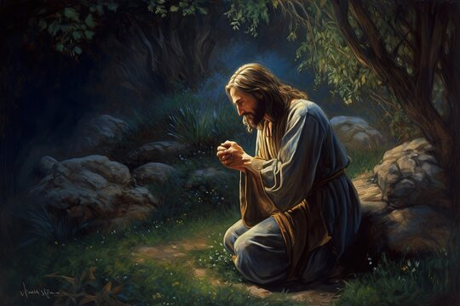

**Time With God, Part 1**

**Jesus Prays**

**Scripture Mark 14:32-42**

I don’t have time to pray….

The most powerful man in the world

has 24 hours in a day to do what he needs done.

The richest man in the world

has 1440 minutes in a day to earn his money.

The most educated man in the world

Has 168 hours a week to learn.

The greatest athlete in the world

Has 365 days in a year to train.

How much time do you have?

MATTHEW:

1. Matthew 11:25-26- While speaking to the Jewish leaders.

2. Matthew 14:23- Before walking on water.

3. Matthew 14:19- Giving thanks to the Father before feeding 5000.

4. Matthew 15:36- Giving thanks to the Father before feeding 4000

5. Matthew 9:13-15- Laying hands on and praying for little children.

6. Matthew 26:26- At the Lord’s Supper.

7. Matthew 26:36-46- In Gethsemane before His betrayal. (He prayed 3 separate prayers.)

8. Matthew 27:46- While dying on the cross, Jesus cried out, “My God, My God, why hast thou forsaken me?”

MARK:

1. Mark 6:46- Before walking on water.

2. Mark 1:35-36- In the morning before heading to Galilee

3. Mark 6:41- Giving thanks to the Father before feeding 5000.

4. Mark 7:31-37- While healing a deaf and mute man.

5. Mark 8:6- Giving thanks to the Father before feeding 4000

6. Mark 10:13-16- Laying hands on and praying for little children.

7. Mark 14:22-23- At the Lord’s Supper.

8. Mark 14:32-42- In Gethsemane before His betrayal. (He prayed 3 separate prayers.)

9. Mark 15:34- While dying on the cross, Jesus cried out, “My God, My God, why hast thou forsaken me?”

LUKE:

1. Luke 3:21-22- At His Baptism.

2. Luke 5:16- After healing people.

3. Luke 6:12-13- Praying all night before choosing His 12 disciples.

4. Luke 9:16- Giving thanks to the Father before feeding 5000.

5. Luke 9:18- Before Peter called Jesus “the Christ.”

6. Luke 9:28-29- At the Transfiguration.

7. Luke 10:21- At the return of the seventy.

8. Luke 11:1- Before teaching His disciples the Lord’s Prayer.

9. Luke 18:15-17- Laying hands on and praying for little children.

10. Luke 22:19- At the Lord’s Supper.

11. Luke 23:31-32- Prayed for Peter’s faith when Satan asked to “sift” him.

12. Luke 22:39-46- In Gethsemane before His betrayal. (He prayed 3 separate prayers.)

13. Luke 23:34- Right after being nailed to the cross, Jesus prayed, “Father forgive them; for they know not what they do.”

14. Luke 23:46- In His dying breath, Jesus prayed, “Father, into thy hands I commend my spirit.

15. Luke 24:30- Prayed a blessing on the bread before He ate with others after His resurrection.

16.Luke 24:50-53- He blessed the disciples before His Ascension.

JOHN:

1. John 6:15- Before walking on water.

2. John 6:11- Giving thanks to the Father before feeding 5000.

3. John 11:41-42- Before raising Lazarus from the dead.

4. John 12:27-28- Asking the Father to glorify His name.

5. John 17:1-26- Prayed for Himself, His disciples, and all believers just before heading to Gethsemane.

There were at least 25 different places where Jesus prayed, some of them were in multiple gospel places. Some of the topics throughout the New Testament includes:

1. Pray without ceasing- 1 Thessalonians 5:17

2. Jesus prays alone (Matthew 14:23, Mark 1:35, Luke 9:18 and Luke 22:39-41)

3. Prayed in public- (John 11:41-42, John 12:27-30)

4. Before meals- (Matthew 26:26, Mark 8:6, Luke 24:30, John 6:11)

5. Before important decisions- Luke 6:12-13

6. Before healing- Mark 7:34-35

7. To do the Father’s will- Matthew 26:36-44

8. After healing- Luke 5:16

9. Taught the importance of prayer- (Matthew 21:22, Matthew 7:7-11, Matthew 5:44, Matthew 6:5-15), (Mark 11:24-26), (Luke 11:9-13, Luke 6:27-28), (John 14:13-14, John 15:7 & 16, John 16:23-24)

10. The Lord’s prayer- (Matthew 18:19-20, Luke 11:2-4)